**“Saarthi App”**

**By: Kumar Sambhav**

**Date: 16th May 2022**

**Introduction*:***

I am thinking to create an app that will help people plan their railway journey.

It will provide users with--

1.) The best train combinations between their boarding station and their destination based on the choice of low-cost plan or minimum duration plan or both.

2.) And when the user reaches the destination city the app will help them get the best hotels and pick up the best restaurants in the city as per their requirement.

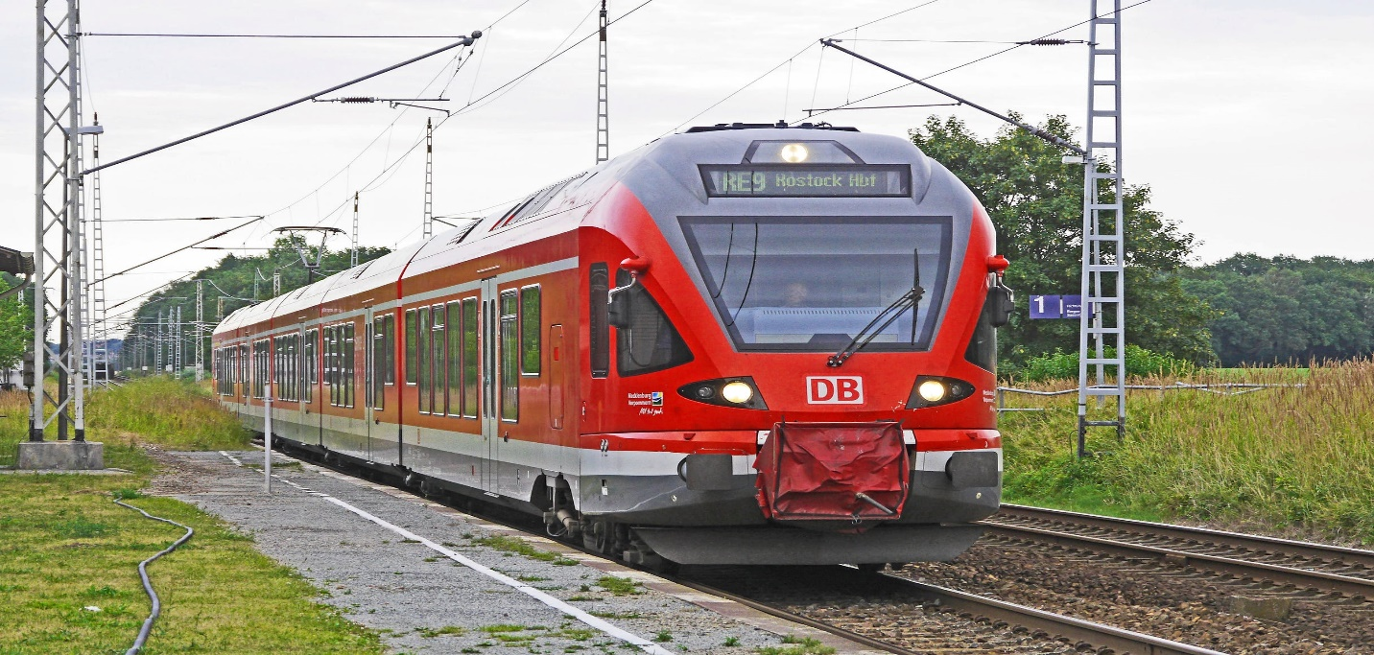

**Market Need Assessment**:

Nowadays, every person has access to the smartphone and prefers to get help and support from technology to get better and fast results. People want their tasks done in cost effective and time efficient way. That is why so many apps in different sectors are very successful.

We can make an application that helps customers plan a low-cost and time saving journey with best train combinations with suitable time and then when they reach the destination, they can get the hotels according to their requirements. Some may want luxury hotels while some may wish for hotels with reasonable prices. We can take the feedback from customers about hotels’ services and improve our application We can provide them with the best restaurants around the tourist accommodations as per the customers favorite cuisines and tourist spot’s famous cuisine.

AI helps conduct data much faster than human intervention, guarantees the accuracy, security, and enables us team to focus on strategic initiatives to make effective AI-powered campaigns.

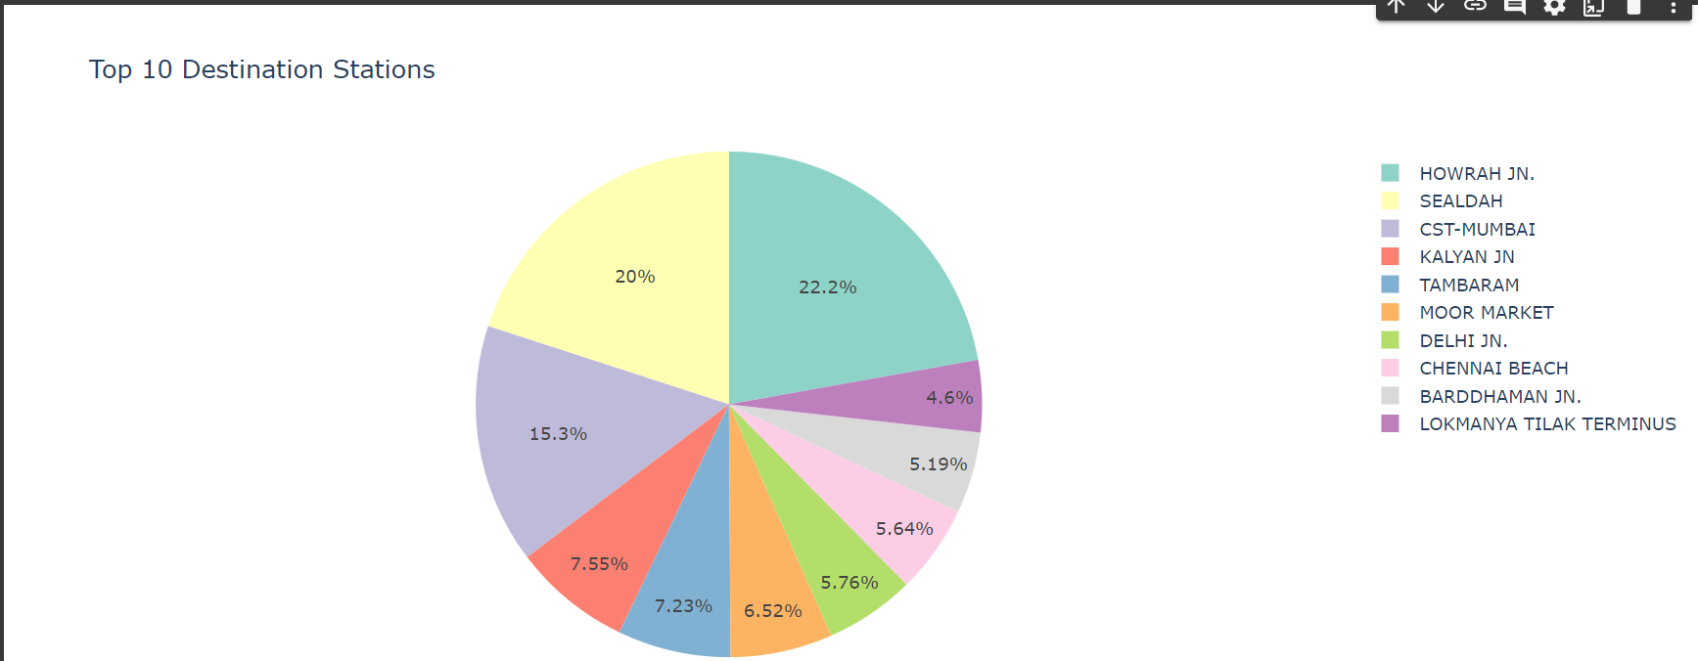

**Target Specification**:

It will directly target the travelling audiences and tourist. Many people are not able to find the best train combinations with the minimum duration journey. They have no other option than to go to agent and buy the tickets from them at higher prices. This application gives them the best train combinations along with the seat availability feature. This application will remove the middlemen and agents as customers can get the best train combination at no cost.

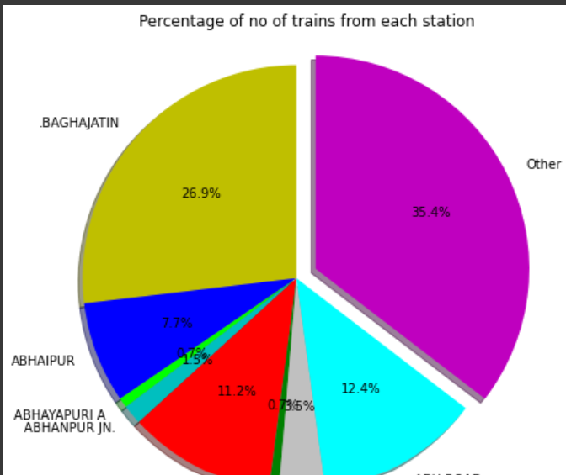

Many customers have hard time finding hotels of their choice (whether he wants cheap hotel or luxury hotel) may get help from this application

Customers can get the restaurants according to their requirements nearby railway stations or hotels.

The application will continuously take feedback from the customers of hotels, restaurants and try to understand the customers’ choice and arrange the results according to their history and choices. It can work with marketing automation to enable translating data into decisions and positively impact the business outcomes.

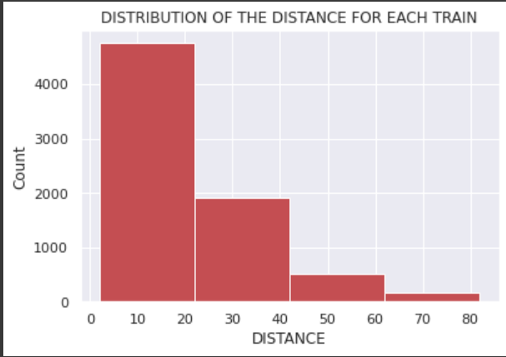

**External Sources**:

<https://www.travelkhana.com/travelkhana/indian-railways-time-table>

This website explains the importance of train time tables and explains the different terms used in railways system. It also explains how does railway set the routes for different trains and how time tables are decided.

The Dataset I have used can be found on Kaggle. It describes the Train name – its stoppages stations, destination station, arrival and departure time,etc.

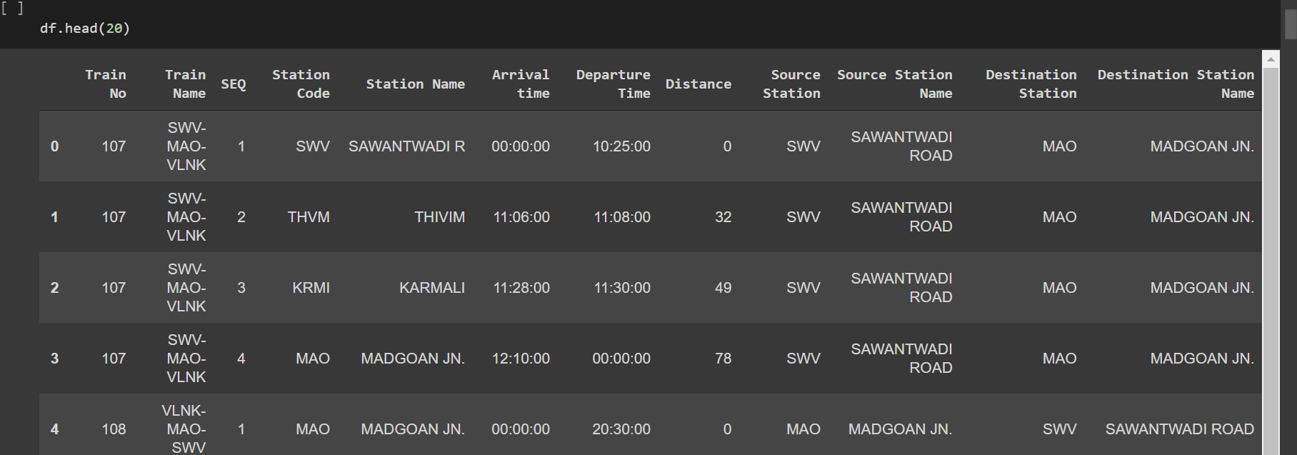

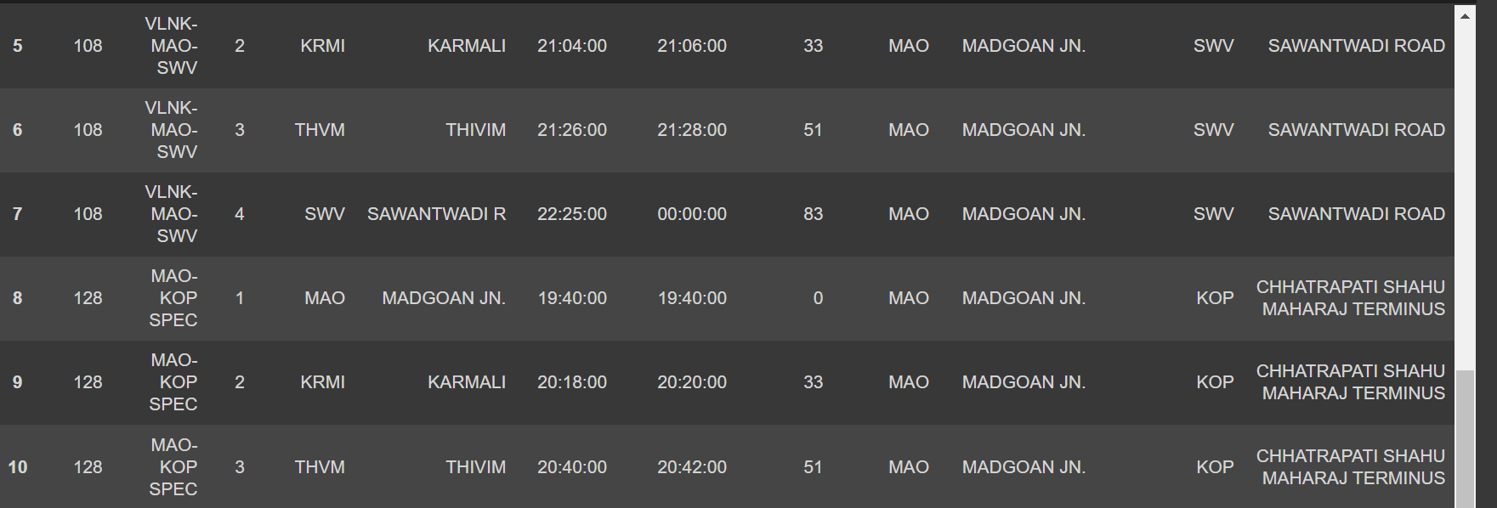

**Applicable Patents:**

International Journal of Interdisciplinary Innovative Research &Development (IJIIRD)

ISSN: 2456-236X Vol. 05 Issue 01 | 2020 -The current patent may incorporate this patent for

the inspiration of the methodology used as well as EDA analysis to some extent.

**Applicable Regulations:**

The patents mentioned above might claim the technology used if the algorithms are not

developed and optimized individually and for our requirements. Using a pre-existing model is off

the table if it incurs a patent claim.

1. Must provide access to the 3rd party websites to audit and monitor the authenticity and

behavior of the service.

2. Enabling open-source, academic and research community to audit the Algorithms and

research on the efficacy of the product.

3. Laws controlling data collection: Some websites might have a policy against collecting

customer data in form of reviews and ratings.

4. Must be responsible with the scraped data: It is quintessential to protect the privacy and

intention with which the data was extracted.

**Applicable constraints**:

1. Requires very large dataset of railways trains along with their timetables, fare prices, train routes and requires expertise in handling big data.
2. **Requires a lot of research to obtain an optimized Machine Learning Algorithm or Deep learning Algorithm that can suggest the customer the best route based on the source and destination stations based on the demands of the user.**
3. Establishing very good UI (User Interface) that can take feedback from the customers of hotels and restaurants and improve the dataset effectively.
4. Thorough understanding of dataset and verification of the results must be performed by the ML Engineer.

**Business Opportunity:**

Substantial amount of tourism opportunities can be seen if the stats can be used by

local tourism firm and government support (At least in India) presents us with a promising future

in product development and comparison. If Someone doesn’t have a lot of capital to spend on

market research and feedback on prototype products. Our service offers just that. We provide a

one stop price comparison, feedback, and comparative analysis all using Machine learning and

automation. This will complement their market research team gain better insights on product and

pricing design .

**Bench marking alternate products:**

There are several websites that help you find the trains between any two given stations but they do not adjust as per individual user and sometimes are unable to provide adequate results.

But this application gives you the right results as per your choices and comfort and suggest alternate routes in case one does not exist.

At the same time, it compares the journey time and fare prices of all the trains on that route and gives you the best train or train combination that serves your purpose.

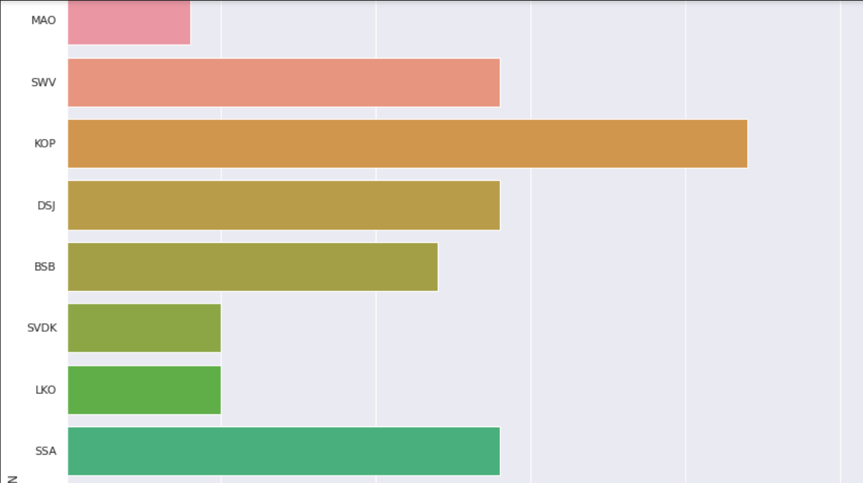

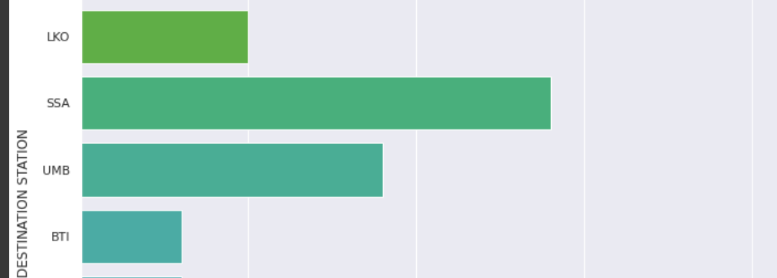

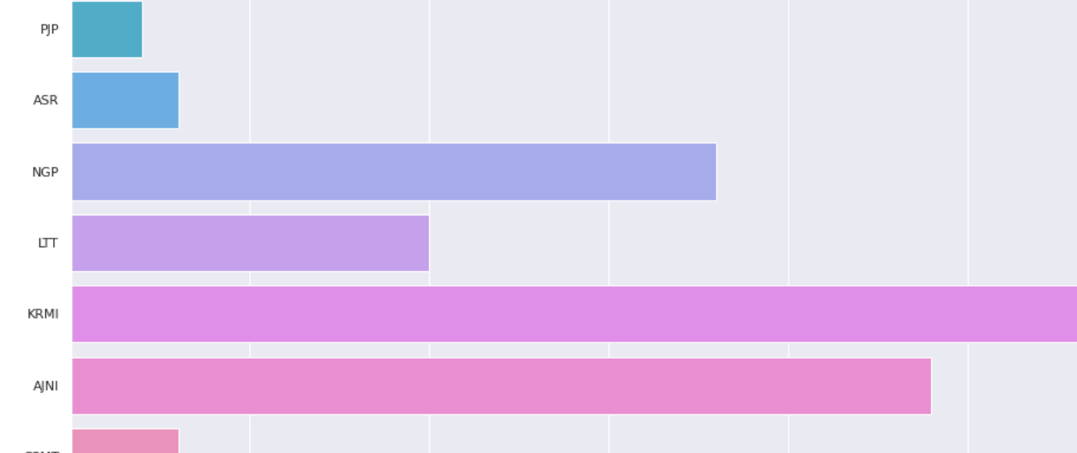

**Concept Generation:**

This product requires the tool of Artificial Neural Network to be written from scratch in order to fulfil all the demands of the application. The application may have many features and ANN will be the most suitable to make this application effective in long run and well-functioning.

A lot of manual supervised deep learning must be performed to optimize the automated tasks.  It will take a lot of research to get the right number of hidden layers and neurons for every layer and the output layer. We will have to work a lot as their will be many different ways a user will want to have the output according to his needs and there will be many features the result will be based on.

**Concept Development:**

The concept can be developed by using the appropriate API (flask in this case) and using Django as framework for the same and for its deployment, The cloud services have to be chosen accordingly to the need.

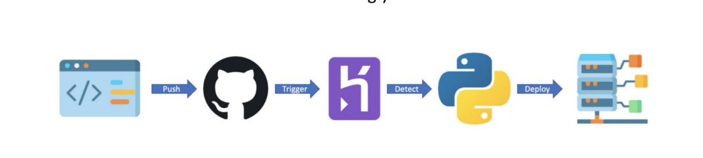

**Final Product Prototype:**

Back End:

Model Development: This must be done before releasing the service. A lot of manual supervised deep learning must be performed to optimize the automated tasks.

1. Performing EDA to realize the dependent and independent features.

2. Artificial Neural Network to be written from scratch in order to fulfil all the demands of the application. The application may have many features and ANN will be the most suitable to make this application effective in long run and well-functioning

3. Algorithm training and optimization must be done to minimize overfitting of the model and hyperparameter tuning.

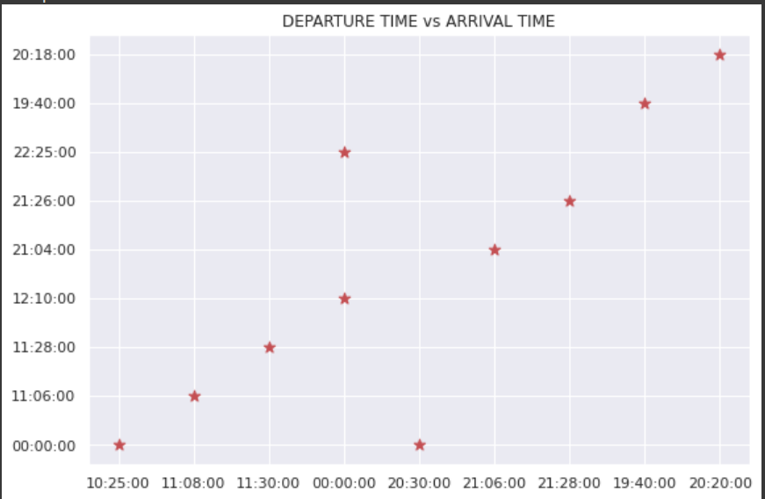

Front End:

1. Different user interface: The user must be given many options to choose form in terms of parameters. This can only be optimized after a lot of testing and analysis all the edge cases.

2. Interactive visualization the data extracted from the trained models will return raw and inscrutable data. This must be presented in an aesthetic and an “easy to read” style.

3. Feedback system: A valuable feedback system must be developed to understand the customer’s needs that have not been met. This will help us train the models constantly.

**Product Details:**

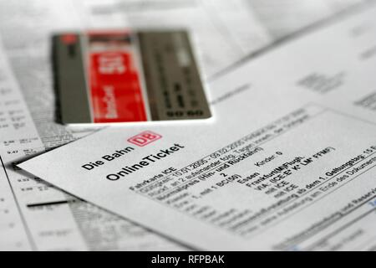

The application will take the filters or inputs from the user asking about the boarding and destination stations, preferred dates of journey, duration of journey he/she wants, etc. and show him the best matched results comparing the travel time, displaying seat availability and trains that best fit the needs of the user.

The data source will be all the trains with features as stoppage stations, duration, arrival and departure times, train numbers, train names, etc.

I have used the dataset from Kaggle for demonstration purpose. But the original dataset will be much larger and more sophisticated. The application will fetch the required data from the Indian Railways website and put the data into the artificial neural network created to get the desired results.

The ANN needed has to be trained for different filters and requirements so that it can perform well when launched. The training part and evaluating the model has to be done several times i.e., it will need large no. of epochs before to achieve great efficiency.

-------------------------------------------------------------------------------------------------------------------------------

**GitHub Link**: <https://github.com/ksambhav21/Indain-Railways-EDA>